Process to add new Component

Definition
There are 10 main defined components:
- Article
- Event
- Form
- Gallery
- News
- Other
- ShortArticle
- SubMenu
- Testimonial
- Title
Each of these can have unlimited defined Layouts and Templates. For example a Form can be contact, login, response or other. More tables can be added for specific needs. See db table -> RED_Components.
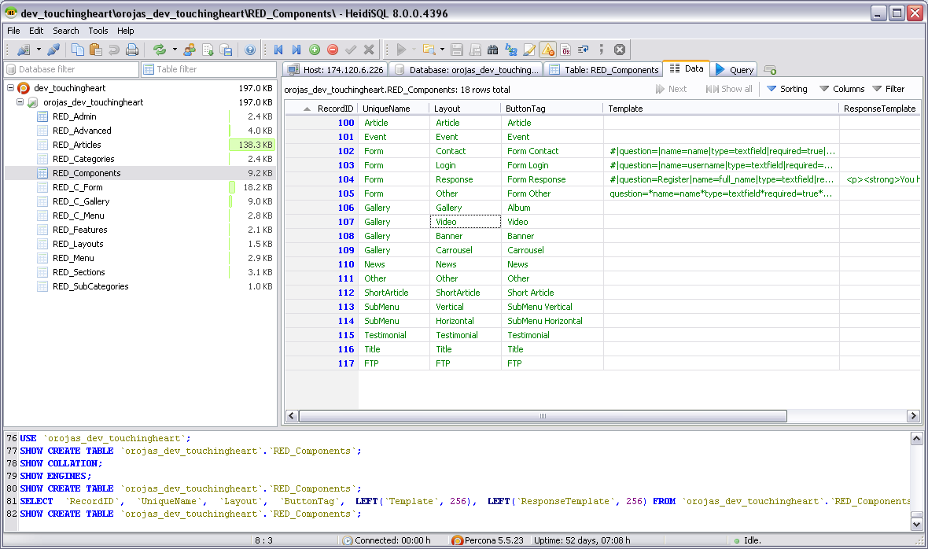

How it works
Each component uses its own code (class), which is called from the wireframe using the URL generated on each page load. You can use any of the following variables:
Define From URL
section, category, subcategory, article.
From Query Array
$recordid, $query, $VarFeatures, $VarPosition, $position, $layout, $limit
You can use your own set of css, javacript & html. Also take advantage of tools like the automatic image resize, which uses the sizes set from db table -> RED_Layouts. Refer to new page layout doc.
Steps
1 - Define UniqueName and Layout component. in db table -> RED_Components
2 - Public Folders
- Add scripts into /js/ folder and call from header @ index.php. check /js/scripts.js
- Add css into /css/ folder and header @ index.php. check /css/style.css
- Construct class & html @ /class/class_component_.php. (Follow class_component_template.php)
- load class from /index.php
- Call class from /class_content.php. Insert the new case using your UniqueName component on top of the component switch (line 79). Follow the same format.
- add images into /images/UniqueName/
3 - Admin Folders
You will need to create independent scripts to handle each of the following requests: new, edit & update.
For any request, you have the option to access another db table for your component, or use the available fields (LongDesc, ShortDesc, VideoSrc, AlbumSrc) in db table -> RED_Articles. Please note that if you need a new db table for any reason, you still need to save the component reference in db table -> RED_Articles to load in the wireframe. Follow the name syntax RED_C_ComponentName
You can create your own set of dropbox technology and use the current options from /admin/bin/post_file.php (UC=UploadCase). By default you are able to add 3 pictures for the component: Features Picture (UC=BigPict), Small Picture (UC=SmallPict), Article Picture (UC=SmallPict2).
Admin controls css are located in /admin/assets/css/cp.css
Follow the instructions on each template:
- Create new script into /admin/bin/new_component_php (Follow new_component_template.php).
  - Edit /admin/bin/post_file.php to add new dropbox.
  - Create insert script into /admin/bin/insert_component_.php (Follow insert_component_template.php).
- Create edit script into /admin/bin/edit_component_.php (Follow edit_ component_template.php).
  - Edit /admin/bin/post_file.php to add new dropbox.
  - Create insert script into /admin/bin/update_component_.php (Follow update_component_template.php).
- Edit /admin/class/ class_add_menu.php to add new component button. Follow the same format.

